**Change the Goliath Server Address**

This article was updated to support v12.0 of Goliath Performance Monitor.

The steps below walk you through changing the Goliath Server IP address. This comes in handy when the Server hosting the application is moved or IP address is changed.

Goliath suggests using the FQDN or DSN name of the server if the IP address may change in the future. Before you use FQDN or DSN ensure the name of the server resolves to the expected IP Address.

1. Connect to the Goliath Server via RDP or Console session
2. Open Windows Services and Stop the **MonitorIT Server Service** & **MonitorIT Agent Service**
   1. Keep this window open as you'll come back to it in a later step
3. Open Windows File Explorer and go to the **Bin** directory inside the install folder
   1. The default location is either "C:\Program Files (x86)\MonitorIT\Bin" or "C:\Program Files\MonitorIT\Bin"
4. Edit the file **GPMServer.cfg** via Notepad and update the **Server** field to the new IP address or FQDN
   1. 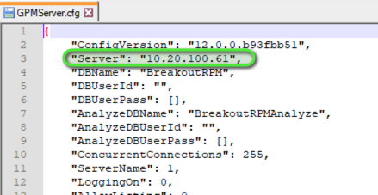
5. Choose File > Save and then close the application
6. Open registry editor by typing ‘regedit’ into the run or search box.
7. Navigate to **HKEY_LOCAL_MACHINE\SOFTWARE\Breakout Technologies\MonitorIT** and update the value for the key **ServerURL** to the new IP address, FQDN, or public DNS address
8. Navigate to **HKEY_LOCAL_MACHINE\SOFTWARE\Breakout Technologies\MonitorIT** and update the value for the key **ServerAddr** to the new IP address, FQDN, or public DNS address
9. Exit registry editor
10. Go back to Windows Services and start the **MonitorIT Agent Service** & **MonitorIT Server Service**
11. Wait about 3-10 mins for the technology to come back online and then connect to Goliath via the new address
12. After confirming the web portal is accessible, you will need to push deploy agents out to the other servers you are monitoring to point them at the new IP. You can find instructions for push deploying an agent here: [Agent Installation via Auto Agent Deployment](https://support.goliathtechnologies.com/hc/en-us/articles/360025164813-Agent-Installation-via-Auto-Agent-Deployment)
    1. Alternatively, you can update the **ServerAddr**key value at **HKEY_LOCAL_MACHINE\SOFTWARE\Breakout Technologies\MonitorIT**or **HKEY_LOCAL_MACHINE\SOFTWARE\WOW6432Node\Breakout Technologies\MonitorIT** on the servers you already have agents deployed on. After updating the key, restart the **MonitorIT Agent Service**on that machine.